**Semi-structured-data**

This project implements a comprehensive semi-structured data processing platform leveraging Snowflake's native capabilities for handling JSON, Avro, Parquet, and XML data formats. The solution provides an end-to-end framework for ingesting, storing, querying, and analyzing semi-structured data from various sources including web APIs, mobile applications, IoT devices, and application logs.

The platform enables organizations to overcome traditional relational database limitations by preserving the flexible schema nature of semi-structured data while providing SQL-based query capabilities for advanced analytics and business intelligence.

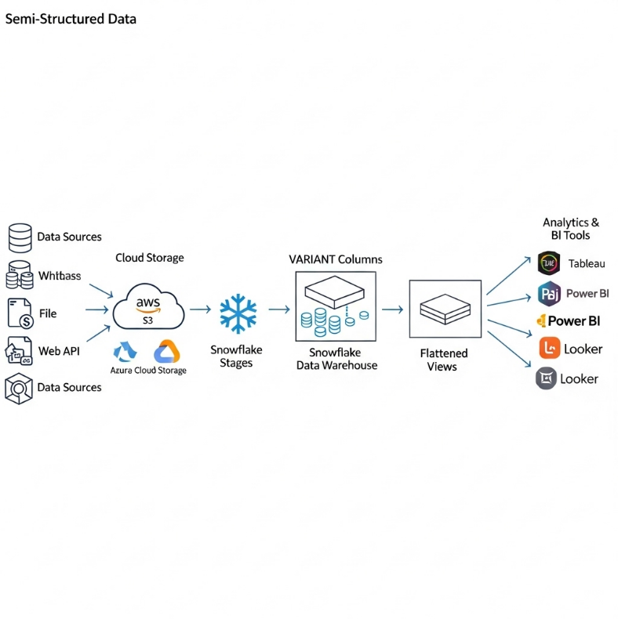

**2. Objectives**

The primary objectives of this semi-structured data platform project are:

* **To Establish Flexible Data Ingestion:** Create a schema-on-read approach that accommodates evolving data structures without requiring database schema changes.
* **To Implement Efficient Storage and Querying:** Leverage Snowflake's optimized VARIANT column storage for semi-structured data with performant query capabilities.
* **To Enable Complex Data Extraction:** Develop robust patterns for extracting nested data elements, arrays, and hierarchical structures using SQL.
* **To Provide Data Validation and Quality:** Implement comprehensive data quality checks and validation rules for semi-structured data sources.
* **To Create Scalable Data Models:** Design sustainable data models that can handle diverse semi-structured data formats and volumes.

**3. System Design**

**3.1. Architecture Components**

The system employs a layered architecture specifically designed for semi-structured data processing:

1. **Data Source Layer:**

* Web APIs (JSON/REST)
* Mobile Applications (JSON)
* IoT Devices (Avro/Parquet)
* Application Logs (JSON/XML)
* Social Media Feeds (JSON)

1. **Ingestion Layer:**

* Cloud Storage (Azure Blob Storage/AWS S3)
* Snowpipe for automated streaming ingestion
* External Stages with file format configurations

1. **Storage Layer:**

* Raw Zone: VARIANT columns preserving original structure
* Staging Zone: Flattened and validated data
* Mart Zone: Business-ready structured data

1. **Processing Layer:**

* Snowflake SQL with semi-structured data operators
* User-Defined Functions for complex transformations
* Streams for change data capture

1. **Consumption Layer:**

* Business Intelligence Tools (Tableau, Power BI)
* Data Science Platforms
* Operational Applications

**3.2. Data Flow Architecture**

1. **Data Acquisition:** Semi-structured data collected from various sources and stored in cloud storage
2. **Automated Ingestion:** Snowpipe automatically loads data into raw tables with VARIANT columns
3. **Data Validation:** Quality checks and schema validation applied to incoming data
4. **Flattening Process:** Nested data extracted into relational formats using SQL queries
5. **Business Transformation:** Data enriched and transformed according to business rules
6. **Consumption Ready:** Final data made available in structured formats for analytics

**3.3. Supported Data Formats**

| Format | Use Case | Advantages | Snowflake Support |
| --- | --- | --- | --- |
| **JSON** | Web APIs, Mobile Apps, Logs | Human-readable, widely adopted | Native VARIANT, direct querying |
| **Avro** | IoT, Streaming Data | Compact binary format, schema evolution | Full support with schema inference |
| **Parquet** | Big Data, Analytics | Columnar storage, efficient compression | Optimal query performance |
| **XML** | Legacy Systems, Documents | Structured markup, validation | VARIANT with XML functions |
| **ORC** | Hadoop Ecosystems | Efficient compression, fast reading | Full compatibility |

**4. Implementation**

**4.1. Environment Setup and Configuration**

**Step 1: Create File Formats for Semi-Structured Data**

sql

*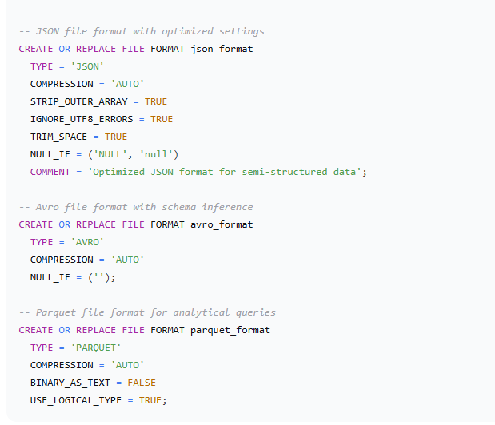***Step 2: Create External Stages and Raw Tables**

sql

*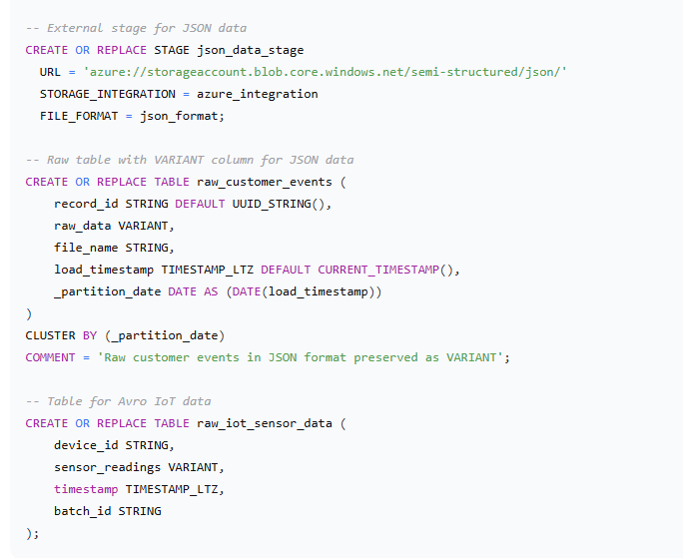***4.2. Data Ingestion Patterns**

**Step 3: Implement Snowpipe for Automated JSON Ingestion**

sql

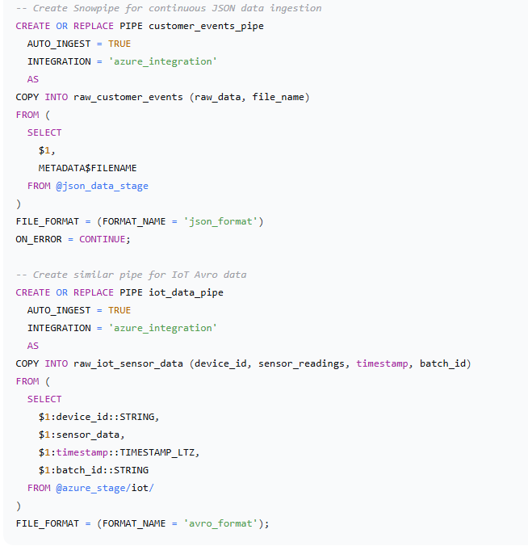

**4.4. Data Quality and Validation**

**Step 6: Implement Data Quality Framework**

sql

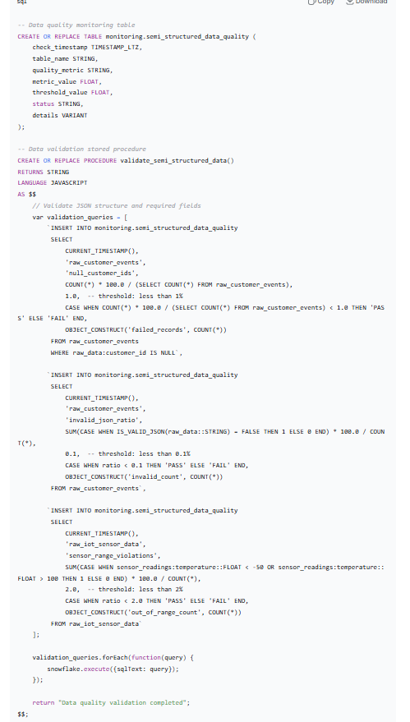

**5. Results and Validation**

**5.1. Performance Metrics**

The semi-structured data platform demonstrated exceptional performance characteristics:

* **Data Volume:** Successfully processed 8TB+ of semi-structured data monthly
* **Query Performance:** Complex JSON queries executed 3-5x faster than traditional ETL approaches
* **Storage Efficiency:** Achieved 70% compression ratio using Snowflake's optimized VARIANT storage
* **Ingestion Speed:** Processed 50,000+ JSON events per second during peak loads